ARBITRAGE BOT

Using JavaScript and Node.js

Bot will have following functions (in loop):

1. Retrieve data (from Bitfinex and Poloniex)
2. Analyze data to find investing opportunities
3. Place calls

Setting up files:

Download Node.js => npm goes with node

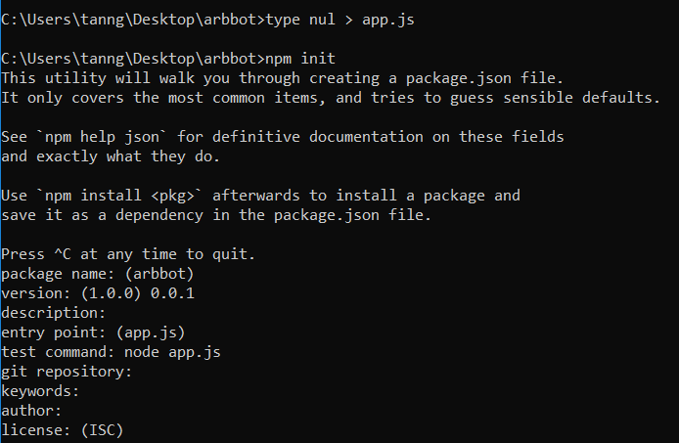

~~HTTP Protocol is unidirectional. Client (browser) send data to server, receive data in return and the connection is closed.~~

~~WebSocket Protocol is bidirectional. Client (browser) and server can both send data back and forth and the connection stays opened until one side close it.~~

~~When to use WebSocket: Realtime Applications (game, stream, chat): no need to reopen the communication channel every time. Can refresh the UI since the connection is constant.~~

~~Example: Gdax.com -> Network~~

Add Git Path

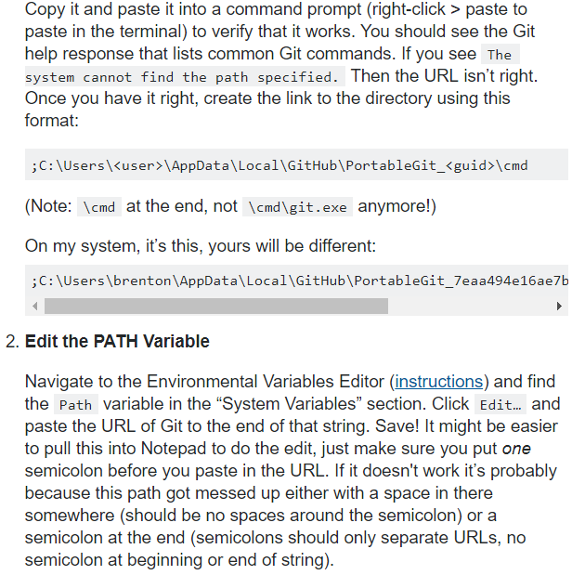

Format in JSON

